**English 11B**  Name   
**Unit 3: American Romanticism**  Hour

**Standards/Objectives**

**RL.11-12.2** Determine two or more themes or central ideas of a text and analyze their   
 development over the course of a text…; provide an objective summary of the text. **RL.11-12.9** Demonstrate knowledge of eighteenth-, nineteenth-, and early twentieth-century  
 foundational works of American literature, including how two or more texts from the  
 same period treat similar themes or topics.  
  
**Objectives:** - Analyze the structure and effectiveness of arguments in transcendentalist essays   
 studied.

**\*\*This assignment is Evidence #1 for the Unit 3 Essays Quiz.\*\***

**Excerpts from *Self-Reliance* by Ralph Waldo Emerson**

1. **Please attach your SMILES graphic organizer to these questions before handing in this assignment!** (Similes, Metaphors, Imagery, **Locate the Main Idea**, Effects of the Writer’s Voice {Mood & Tone}, Summary)  
  
2. **Lines 26-29.** What is implied by Emerson’s use of the word “sacred” in theses lines? Why does he believe that one should follow his or her nature?

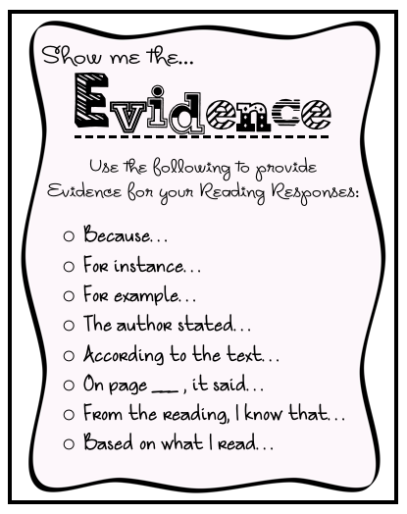3. **Lines 35-38.** What does Emerson say is easy to do? What does he say a great person should be able to do?

4. **Lines 39-42.** What does Emerson say is one consequence of being a nonconformist?

5. **Line 61.** Emerson says, “To be great is to be misunderstood.” What do you think he means by that?

6. Tell whether you agree with each of these quotations from “Self-Reliance,” and explain why or why not.  
 (a) “Envy is ignorance…imitation is suicide.”  
  
 (b) “Nothing is at last sacred but the integrity of your own mind.”  
  
 (c) “What I must do is all that concerns me, not what the people think.”

7. What characteristics of Transcendentalism do you see in this essay? \*\***Support your ideas with at least one example (quote, page number) from the text.\*\***