**English 11B**  Name   
**Unit 1: The New World**  Hour

**Standards/Objectives**

**RL.11-12.4** Determine the meaning of words and phrases as they are used in the text…; analyze the  
 impact of specific word choices on meaning and tone… **RL.11-12.9** Demonstrate knowledge of eighteenth-, nineteenth-, and early twentieth-century  
 foundational works of American literature, including how two or more texts from the  
 same period treat similar themes or topics.  
  
**Objectives:** - Identify and explain elements of Puritan literature.  
 - Explain the role of religion in early American life.

**\*\*This assignment is Evidence #2 for the Unit 1 Quiz.\*\***

***To My Dear and Loving Husband* and   
*Upon the Burning of Our House* by Anne Bradstreet**

1. **Please **attach your SMILES poem annotations** to these questions before handing in this assignment!** (Similes, Metaphors, Imagery, Locate the Nouns and Pronouns, Effects of the Poet’s Voice {Mood & Tone}, Summary)  
  
2. In “To My Dear and Loving Husband,” what emotions does Bradstreet express toward her husband? List words and phrases that support your ideas.

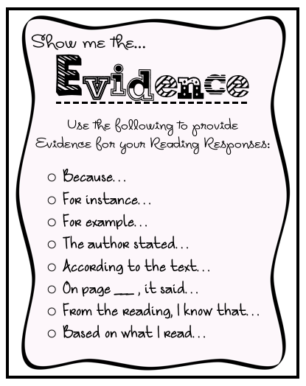3. **Upon…** **Lines 13-18.** How does Anne Bradstreet view the loss of her house?

4. **Upon…** **Lines 43-54.** What is Bradstreet comparing to a house in this metaphor?

5. How does Anne Bradstreet feel about wealth and material goods? \*\***Support your ideas with at least one example (quote, page number) from the text.\*\***6. Based on what you know about Anne Bradstreet and  
 about Puritan religious beliefs, how do you think Anne  
 would have reacted if her husband had died in the fire  
 that burned her house? Why?  
  
7. How would you describe Anne Bradstreet’s views of God and heaven? \*\***Support your ideas with at least one example (quote, page number) from the text.\*\***